

|  |  |
| --- | --- |
| **Hands-on Exercise No. 4**  **DigiSkills**  **2.0 Batch-05 Freelancing** | **Total Marks: 10**  **Due Date: 07/09/2023** |

**STUDENT NAME:**

**Uzma Ejaz**

**Problem Statements:**

**A good profile contains: • A Profile Picture with a natural look. • A catchy Tagline. • A well-written Profile Description. • Well-crafted Services with all relevant details. • Skill reflecting Portfolio items.**

**1. Profile Picture**

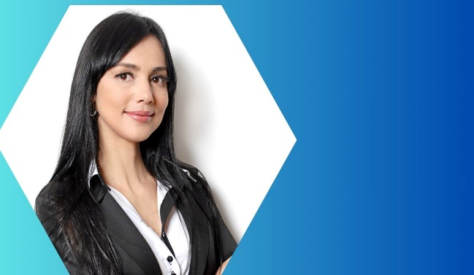

**2. Tagline**

1. **A responsive WordPress website design and developing with install best plugin and WordPress SEO.**

**3. Profile description**

**Hi, I'm as a professional web designer and developer, I am dedicated to building smooth and functional websites. I specialize in all things WordPress, including customizations and theme development. With my expertise, you can expect a clean, unique, and professional website that will enhance your online business. Don't wait any longer! You've come to the right place for a WordPress designer and developer with plenty of experience in creating beautiful designs to turn your dream into reality.**

**4. Skills**

1. **WordPress Installation and Setup**
2. **Website Security and Maintenance**
3. **Search Engine Optimization (SEO)**
4. **Troubleshooting and Problem Solving**
5. **Theme Customization**

**5. Portfolio items/screenshots**

